Hillcrest Animal Clinic
Spring 2019 Newsletter

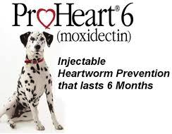

It’s Heartworm Testing Time for Your Dog
With the warmer weather, mosquitoes carry an increased risk of
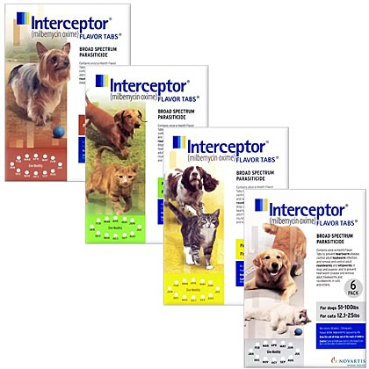
heartworms for your dog. Heartworms are transmitted when a mosquito bites an infected dog, then bites your dog. We recommend testing your dogs and outside cats for heartworms and starting them on heartworm preventative to stop this potentially life-threatening disease. Heartworms are easy to prevent, but very difficult and expensive to treat. With a simple blood test, we can detect the presence of heartworms within your dog. Call today to schedule your heartworm check!

Proheart 6 is a heartworm preventative that lasts for 6 months. It can only be given to adult dogs. You can give 2 doses a year instead of dealing with 12 pills.

Interceptor is a heartworm preventative given in monthly pills. Can be given to puppies and growing dogs as well as adults.

Pick up Interceptor or Proheart today!

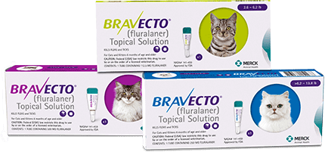
Flea/Tick Preventative- Bravecto For Cats!
Cats everywhere can now experience the Bravecto 12-week difference!
Whether your cat goes outdoors or stays inside, continuous flea and
tick protection is important. With Bravecto, you can give your cat 12 weeks of protection against fleas and ticks with a single treatment.
This makes it easy for you to provide long-lasting coverage to your cat,
without having to worry about giving frequent treatments. With just one
dose, your cat is all taken care of, so you can enjoy life with your cat,
without any worries. We also still carry Bravecto for dogs!! Stop in
this season and pick up Bravecto for your dog and cats!!

$12 Spring Farm Calls are back!
See next page for more information!
Zone 1 dates Zone 2 dates Zone 3 dates  Waverly, Greenwood, Eagle, Walton, Pioneers Park,  Ceresco, Davey, Raymond, Palmyra, Bennet, and Emerald, Malcolm,  Wahoo, and Ashland area Hickman area and Denton area  Early Vaccine and Coggins Only!!  Friday, March 29 Wednesday, March 27 Monday, March 25  (Afternoon) (Morning) (Afternoon)  Dr. Molly Dr. Dana Dr. Molly  Regular Farm Call days  (Vaccines, Coggins, Dentals, and Sheaths)  Wednesday, April 10 Tuesday, April 2 Thursday, April 4  (Afternoon) (Afternoon) (Morning)  Dr. Dana Dr. Dana Dr. Molly  Thursday, April 18 Tuesday, April 16 Friday, April 12  (Afternoon) (Afternoon) (Morning)  Dr. Dana Dr. Dana Dr. Molly  Monday, April 22 Friday, April 19 Wednesday, April 24  (Afternoon) (Morning) (Morning)  Dr. Molly Dr. Molly Dr. Dana  Friday, May 3 Monday, April 29 Tuesday, May 7  (Afternoon) (Morning) (Morning)  Dr. Molly Dr. Dana Dr. Dana  Monday, May 13 Wednesday, May 8 Thursday, May 16  (Morning) (Afternoon) (Afternoon)  Dr. Dana Dr. Molly Dr. Molly  $12 Farm Calls!  - Back by popular demand! Hillcrest has brought back the discounted farm calls for select days this spring. Please make sure we have a current phone number in case we need to reach you on the day of your appointment.  - Doctors Dana and Molly will be available to give spring vaccines, check teeth, perform dental floats, clean sheaths, get fecal samples, and complete coggins tests.  - We ask that owners are flexible with times as appointments may be subject to change. You will be given a range of time in which the doctor will be there. Doctors have the potential to be out all day if there’s enough interest in a particular day.  - The first week is for vaccine, coggins, health certificates and fecal samples only. Due to cold weather we will not be doing any dental floats or sheath cleanings. We can schedule a follow-up appointment in April/May.  - A great way to save is to give your horse a Spring Wellness Exam during your farm call for only $108!!!  - Please note: Any appointments that will require more time such as a lameness exam will need to be scheduled on a different day.  - If you’re part of a boarding or training barn, please schedule a barn day. |  | $108 Spring Wellness package includes:  Full Physical Exam  Body Condition Scoring  Nutritional Consult  Fecal Egg Count  Oral Exam  Vaccinations:  Rabies  West Nile Virus  Eastern/Western/Tetanus  Flu/Rhino  Hillcrest Animal Clinic  9011 Branched Oak Road  Lincoln, NE 68517  402-785-1025  March 25 -May 16 2019

How to Help Your Cat Get More Exercise
Has your cat turned into a fluffy couch potato? Energetic kittens can quickly become overweight cats if they don't get enough exercise. Luckily, your feline friend can become more active with a little help from you.
Inactivity Increases the Risk of Health Issues
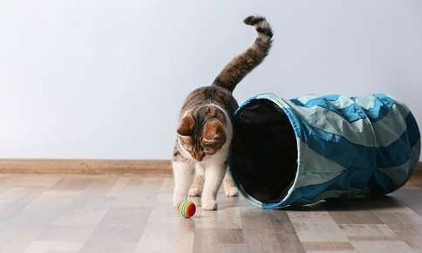
Your cat needs regular exercise to keep his or her heart, lungs, muscles, and bones strong and healthy. Lack of exercise and subsequent weight gain can lead to a slew of health problems, including:
- Arthritis
- Strain on the Heart
- Diabetes
- Urinary Tract Infections
- Decreased Lifespan
- High Blood Pressure
- Skin Infections
- Fatty Liver Disease
Daily Exercise is the Key to Good Health
Regular exercise sessions play an important role in your cat's health. A little exercise not only prevents your pet from gaining weight, but also relieves boredom and keeps your furry friend's mind sharp. Exercise sessions don't have to be long. Your pet will benefit from two or three sessions per day that last five to 15 minutes.
How Can I Increase My Cat's Activity Level?
These cat-approved activities and toys can help your furry friend improve his or her fitness level:
- Fishing Pole. The kitty fishing pole is a classic, inexpensive piece of feline exercise equipment. Your cat will love chasing the dangling "bait" at the end of the fishing line while you swish the rod back and forth. Fishing poles are available at pet supply stores, or you can make your own using a rod or dowel, a securely attached string, and a soft toy or feathers.
- Chase the Light. Any game that mimics chasing prey, even if the prey is only a dancing light beam, is sure to be popular with your cat. Wave a small flashlight or laser pointer at the wall and watch your cat attempt to catch it the bouncing beam.
- Climbing Towers. Indulge your cat's natural love of climbing with a store-bought or homemade climbing tower. Be sure the tower also includes plenty of cushioned perches for resting.
- Battery-Operated Toys. Some cats love pouncing on battery-operated birds and mice that make noise and light up. Toys that feature quick movements are more likely to entice your cat.
- Treat-Dispensing Toys. Balls and other toys that contain compartments for treats increase activity and encourage ingenuity. The toys only dispense the treats when they're positioned precisely, which helps ensure that your pet gets a healthy workout.
- Paper Balls and Boxes. You don't have to spend a lot to encourage your cat to move. A crumpled up paper tossed on the floor can provide hours of fun. Boxes are irresistible for most cats, particularly when you put a toy inside or connect a few boxes together.
Current Deworming Strategies
With spring right around the corner, we are eager to work together to develop a smart, specific deworming program that fits your horse’s needs. It can be challenging to strike a healthy balance when developing a deworming program; on one hand, it is important to minimize your horse’s parasite load, but overuse or misuse of deworming products can lead to resistance. Circumstances to consider in developing a deworming protocol for your farm include: Egg shedding classification of individual animals on the farm, exposure to new animals (travel, boarding, shows), and number of animals housed. It is important to develop a deworming strategy which is specific to your facility, your animals and their current risk of exposure.
The major groups of parasites, include:
-Large Strongyles
-Small Strongyles
-Roundworms (ascarids)
-Tapeworms
-Pinworms
-Bots
There are a number of approaches to deworming, which include some combination of the following:
Oral deworming medications, by drug class:
-Macrocyclic lactones (Ivermectin, Moxidectin – ex. Zimectrin Gold, Quest)
-Benzimidazoles (Fenbendazole, Oxibendazole – ex. Panacur, Anthelcide EQ)
-Tetrahydropyrimidines (Pyrantel pamoate, Pyrantel tartrate – ex. Strongid)
-Prazino-isoquinolines (Praziquantel - ex. Equimax, Quest Plus)

Daily dewormers: Help prevent new infections, but don’t resolve existing infections, and do not kill bots. Not to be used as a sole method of deworming.

One dose dewormers: Given once orally. Generally, control multiple stages of infection.
Manure management to decrease exposure to eggs:
-Regular manure cleanup in stables and pastures
-Rotating pastures
-Feeding off the ground and away from manure
-Don’t drag/harrow pastures to break up manure unless planning on keeping horses off pasture for several weeks
An important topic in recent years is parasite resistance to dewormers. Resistance is increasingly common, as some parasites can no longer be treated by certain drugs. A current recommendation to prevent resistance is for horse owners to submit a fecal sample annually for a fecal egg count, on their horses. The fecal count will classify them as low, moderate or high shedders and identify the type of parasites present. From there, an appropriate course of treatment for individual animals can be determined. To ensure that there is no resistance, submitting a second fecal sample in animals with a high parasite load, 8-12 weeks after deworming, can be performed to ensure that egg counts have been significantly reduced.
Fecal tests are cost effective for the information they provide. The protocol that can be developed from this information may result in less money being spent on deworming products through targeted treatment and peace of mind that resistance is being managed.
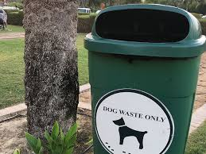
Giardia in Dogs and Cats
Giardia is a common microscopic intestinal parasite that affects dogs, cats, and people. Pets become infected by ingesting the infectious offspring (cysts) after they are shed in another animal’s feces. Once these protozoa enter the intestines, the infected animal develops giardiasis-a disease that interferes with digestion and the absorption of nutrients.
Standing water is often a source of the parasite. Giardia cysts are hardy and can survive for several months in a cool, damp environment. They are also resistant to freezing and to chlorination in water. Giardia is very common in kennels, pet stores, dog parks, and animal shelters because of the dense populations.
Diarrhea is the most common symptom of giardiasis, and may be acute or chronic; however, many pets have no symptoms at all. Stools may be loose intermittently, so many owners assume their pets had a temporary reaction to something they ate, and often don’t bring them in to be examined. Other symptoms include nausea, vomiting, weight loss, and excess gas. Dehydration may also occur, especially in younger pets. There is no routine preventative medication for giardia; however, the intestinal infection can be treated. Because giardia is not shed in every stool sample, we will need to repeat fecal tests to ensure the infection is gone.
To help prevent pets from getting giardia, don’t allow them to drink from outdoor water sources, keep feces picked up, and try to avoid walking your pet where other animals have left feces. Be sure to have your pet’s stool sample checked every 6-12 months to rule out this pesky parasite.

